**//Program to list the files in a folder**

package consoleIOPrograms;

import java.io.*;

**class ListFiles**{

public static void main(String[] args){

File[] f= listingFiles("D:\\Console");

for(File file : f){

System.out.println(file.getName());

}

}

public static **File[] listingFiles**(String fileName) {

File[] files=null;

File file = new File(fileName);

if (file.exists()) {

files = file.listFiles();

}return files;

}

}

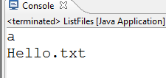

**Program to create folder inside a folder upto 5 levels**

package consoleIOPrograms;

import java.io.File;

import java.io.IOException;

public **class NestedFolder** {

public static void main(String[] felight) throws IOException{

nestedFolder("D:\\Console\\a\\b\\c\\d\\e");

}

static **void nestedFolder**(String fileName) throws IOException{

File file = new File(fileName);

file.mkdirs();

System.out.println("Files created!!");

}

}

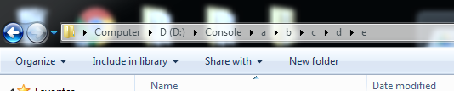

**Program to find the last MOdified time of a folder**

package consoleIOPrograms;

import java.text.SimpleDateFormat;

import java.util.Date;

import java.io.File;

public **class LastModified** {

public static void main(String[] felight)

{

File file = new File("D:\\console");

long mt = file.lastModified();

System.out.println(mt);

Date date=new Date(mt);

SimpleDateFormat dt = new SimpleDateFormat("yyyyy-mm-dd hh:mm:ss");

String dateText = dt.format(date);

System.out.println(dateText);

}

}

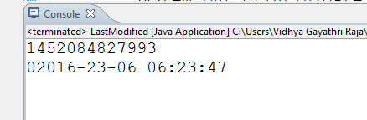

**/\*\***

**\* PROGRAM: Get File filled with Random Data upto 100MB**

**\*/**

package consoleIOPrograms;

import java.io.File;

import java.io.FileWriter;

**/\*\***

**\* @Submitted By: Vidhya Gayathri**

**\*DATE: 6-01-2016**

**\*/**

public **class RandomData** {

static final String CharSet="abcdefghijklmnopqestuvwxytABCDEFGHIJKLMNOPQRSTUVWXYZ0123456789";

public static void main(String[] args)throws Exception {

long start=System.currentTimeMillis();

File file=new File("D:\\Vidhya Java\\Console\\Hello.txt");

file.createNewFile();

FileWriter writer=new FileWriter(file);

int i=0;

System.out.println("Hello! its random filling upto 5MB!\n Please Wait..\n");

while(file.length()<=(2*1024*1024))

{

i++;

writer.write(" " + Math.random());

}

writer.flush();

writer.close();

long end=System.currentTimeMillis();

System.out.println("Time Taken to Fill: "+(end-start)/1000f+" seconds");

}

}

